**Capstone Project - The Battle of Neighborhoods**

**1. Discussion and Background of the Business Problem:**

**Problem Statement:** Prospects of a Lunch Eating Joint close to College Areas in Tokyo, Japan.

Tokyo is one of the most populous metropolitan cities in the world. Currently ranked in the top 5 of global economic power index. So, this makes Tokyo as one of the best places to start with a new business opportunity.

During the daytime, especially in the morning and during the lunch hours, campus areas around colleges provide huge opportunities for Eating joints business. Reasonably priced shops are usually always full during the breakfast and lunch hours (11 am - 2 pm) and, given this scenario, we will go through the pros and cons of opening a breakfast cum lunch eating joint in highly dense college places. Usually the profit margin for a decent food joint lies within 15−20% range but, it can be higher, as we will be discussing here more in detail. The core of Tokyo is made of 23 wards (municipalities) but, will be later choosing the 6 busy business wards of Tokyo — 'Odaiba','Shinjuku','Kinshicho','Shinagawa','Shibuya','Ikebukuro', to target the college students.

We will discuss all the points one by one. First, I would like to outline the audience that would be interested in this case study, followed by the data which would be used to complete the analysis.

**Target Audience**

These days most of the information is available over the internet but those answers are mostly based on the personal preferences and experiences of the people. This piece of information is more data-driven based analysis and with better recommendations. So, Which kind of clients/people or a group of people would be interested in this project -

- Business personnel’s who want to invest in a business or open a restaurant. This analysis will be a comprehensive guide to start or expand restaurants targeting the large pool of students in Tokyo during lunch hours.

- Freelancers who love to open their own restaurant as the side business. This analysis will give them an idea, how good it is to open a restaurant along with the pros and cons of this restaurant business.

- New comers in the city/Students/Freshers, to find reasonable lunch/breakfast place closer to their colleges.

- Students/Professionals who are interested in Data Science and want to implement some of the most used Data Analysis methods to obtain necessary data, analyse it, and conclude it.

**2. Data Preparation:**

**2.1 Scrapping Tokyo Wards Table from Wikipedia**

Special Wards of Tokyo page from Wiki (<https://en.wikipedia.org/wiki/Special_wards_of_Tokyo>) is used to scrap the table to create a data-frame. Requests and Beautifulsoup4 libraries will be used to scrap and create a data-frame with Ward names in Tokyo, Area, Population and 1st Major District.

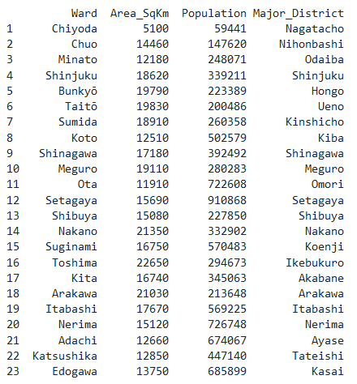

**2.2. Getting Coordinates of the 1st Major Districts : Geopy Client**

The next step is to capture the coordinates of these 1st major districts using geocoder class of Geopy client.

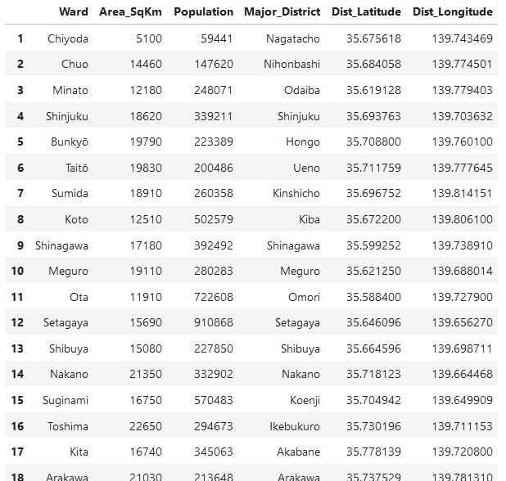

**2.3. Average Land Price in Major Wards of Tokyo: Web Scrapping**

Another web-page (<https://utinokati.com/en/details/land-market-value/area/Tokyo/>) would be used to scrap the table and capture the average the average land price of these Major districts in a dataframe. This factor will later help us in selecting the best districts to open a restaurant.

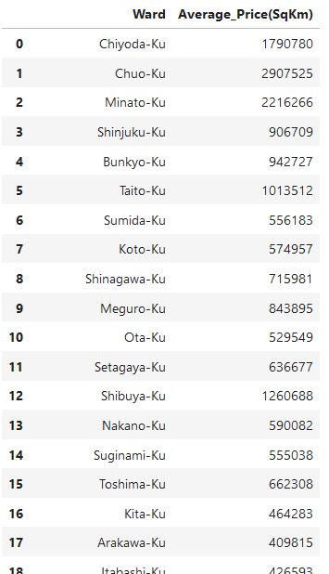

**2.4. Using Foursquare Location Data:**

Foursquare (<https://developer.foursquare.com/>) data is very comprehensive and it powers location data for Apple, Uber etc. For this business problem, Foursquare API is used to retrieve information about the popular spots around these 6 Major Districts of Tokyo. The popular spots returned depends on the highest foot traffic and thus it depends on the point of time when the call is made. So, we may get different popular venues depending upon different time of the day. The API call returns a JSON file and in-turn it is stored as dataframe.

